January 15, 2025

Kenneth Spencer
Benton County Treasurer
620 Market St
PO Box 630
Prosser, WA 99350

RE: 2025 Tax Year Property Tax Certification

Dear Kenneth,

This is to confirm that 2025 tax year property taxes were certified to you
via PACS certification process on January 15, 2025.

The total Real and Personal Taxes (excluding omitted property tax and
late penalty tax for personal property) is:

$ 318,402,817

The attached worksheet shows a breakdown of the various taxing districts
within Benton County. Tax dollars are rounded to the nearest dollar for this report.

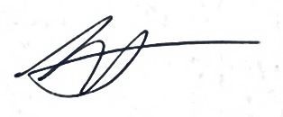
Sincerely,

Bill Spencer
Benton County Assessor

Cc: Benton County Board of County Commissioners
Benton County Auditor

